**Brief content of lectures on discipline Biotechnology of Agricultural Plants**

**L. 1** *Introduction to biotechnology. Plants biotechnology*

**History of Plant biotechnology**

**Hybrid breeding**

**Modern Plant breeding**

**Why plant biotechnology?**

The word "biotechnology" was first used in 1917 to describe

processes using living organisms to make a product or run a process, such as industrial fermentations.

**Biotechnology** began when humans started to plant their own crops, domesticate animals, ferment juice into wine, make cheese, and leaven bread.

***Present definition of biotechnology*** “Any technological application that uses biological systems, living organisms, or derivatives theory, to make or modify products or processes for specific use’’

**The field of plant biotechnology**

is concerned with developing ways to improve the production of plants in order to supply the world’s needs for food, fiber and fuel.

Plants provide us with many pharmaceuticals and industrial (*фармацевтика и промышленность*) compounds.

As our population grows, our needs also grow.

**To increase the quantity of crop production as well as to produce specific characteristics in plants, biotechnologists are using selective gene techniques.**

**History of Plant biotechnology**

Early Plant breeding

Humans domesticate crops.

• Breed plants to further improve desirable characteristics.

Plant breeding 12,000 years ago

**Traditional plant breeding** selects mutants for best yield and quality (e.g., tomatoes).

1. **Classical Plant breeding.**

**2. Cross-breeding to strengthen traits.**

Charles Darwin publishes the theory of evolution by natural selection. The founding of the science of genetics.

* Gregor Mendel discovers the laws of inheritance by studying flowers in his garden. The science of genetic begins.

**Hybrid breeding**

Two parental lines of normally outbreeding species are inbred through several self-pollinations.

• When crossing such lines the first generation has hybrid vigour.

• The vigour gradually disappears over the next generations so new sowing seeds have to be purchased every year .

• Selection operates on desirable traits, not on survival in the wild.

**Modern Plant breeding**

A basic type of modern plant breeding:

- Mutation breeding

- Green revolution

- Plant tissue culture breeding

**Mutation breeding**

Seeds are treated with either radiation or mutagenic chemicals to induce larger or smaller

changes in the genes.

- The mutations are at random over the genome.

- Usually mutation results

in a loss of function of genes or change of function.

**Green revolution (1960-1970)**

Green revolution’ leads to greatly increased crop yields based on the incorporation of **dwarfing genes** discovered by Norman Borlaug and the widespread use of agrochemicals.

**Plant tissue culture breeding**

The process of selectively mating plants in aseptic culture.

- Embryo rescue

- Somaclonal variation selection

- Somatic hybrid (i.e. fusion protoplast).

- Generation of haploid (i.e. anther/microspore culture)

Highlights of Plant tissue culture

1902. Gottlieb Haberlandt proposed that all cells are totipotent. Totipotent.

* Totipotency (Lat. *totipotentia,* "ability for all [things]") is the ability of a single [cell](https://en.wikipedia.org/wiki/Cell_(biology)) to divide and produce all of the differentiated cells in an [**organism**](https://en.wikipedia.org/wiki/Organism)**.**
* **Spores** and **zygotes** are examples of totipotent cells.
* In the spectrum of cell potency, totipotency represents the cell with the greatest **differentiation** potential, being able to differentiate into any [**embryonic**](https://en.wikipedia.org/wiki/Embryo) cell, as well as extraembryonic cells. In contrast, pluripotent cells can only differentiate into embryonic cells

**History of Plant biotechnology**

**1904**

**Hanning isolated nearly mature zygotic embryos from seeds of Crucifers and successfully grew them to maturity in a defined medium.**

**1925**

**Laibach isolated and grew embryos of interspecific cross *Linum perenne* and *L. austriacum* that aborted in vivo**

**1948**

Folke Skoog discovered that kinetin could induce organogenesis in callus culture of tobacco.

**1957.**

**Skoog and Miller demonstrated the effects and interaction of phytohormones**

**Auxin : cytokin > 1 root formation**

**Auxin : cytokin <1 shoot formation**

**Auxin : cytokin = 1 callus formation**

**History of Plant biotechnology**

**1964**

Haploid plants derived from cultured Datura anthers

**1972**

First interspecific hybridization of Nicotiana sp. by fusing protoplast

**1974**

Haploid plants derived from cultured tobacco microspores

**1977**

Successful integration of T-DNA in plants.

**Two major areas of modern plant biotechnology:**

- **Plant Tissue Culture (plants cloning)**

**Recombinant DNA technology (gene cloning)**

Why plant biotechnology?

Human population is rapidly outgrowing.

Worlds’ current status

For higher yield

Conventional Breeding

Ideotype Breeding

Hybrid Breeding

Wide Hybridization

Mutation Breeding

Germplasm Breeding

*The scope of plant biotechnology*

**Plant genetic engineering**

**Plants micropropagation**

**Plant mutation cloning**

**Plant cells technology**

**Impact of plant biotechnology**

More crop yield

More money

**Environmental impact**

In vitro conservation

Pesticide reduction

Health impact Society impact

More food

Better food

Society impact

* **Plant Tissue Culture (PTC):**
* **Plant tissue culture is the sterile, in vitro cultivation of plant parts. Plants have the ability for differentiated cells revert to an undifferentiated state called callus.**
* **These cells will then divide and then differentiate back to somatic embryo cells that will regenerate the entire plant.**
* **Plant Tissue Culture (PTC):**
* Plants cultured in vitro yield thousands of genetically identical plants (clones) from a single plant.
* This process is called **micropropagation** and is used to commercially propagate plants asexually.
* The rapid multiplication allows breeders and growers to introduce new cultivars much earlier than they could by using conventional propagation techniques, such as cuttings.

**Plant Tissue Culture (PTC):**

**Through the use of biotechnology, desirable genetic traits can be transferred from one organism to another by transfer of DNA.**

**Many more plants with the desirable DNA can be regenerated from small pieces of the transformed plant tissue.**

**Examples of plants produced using tissue culture include the large variety of ornamental plants; agricultural crops such as strawberry, banana, potato, and tomato; and a variety of medicinal plants.**

Plant Tissue Culture (PTC):

**Commercial tissue culture involves exposing plant tissue to a specific regimen of nutrients, hormones, and light under sterile conditions to produce many new plants over a very short period of time.**

**L.2.** *Micropropagation technologies of plants. Technology for production of virus-free plants.*

*Micropropagation technologies of plants.*

*What is Tissue Culture? Types,*

*Techniques and*

*Major Steps of Tissue Culture (Plants)*

*Process*

*Plant tissue culture is a collection of techniques used to maintain or grow plant cells, tissues or or-gans under sterile conditions on a nutrient culture medium of known composition.*

*Plant tissue culture is widely used to produce clones of a plant in a method known as micropropa-gation.*

*Different techniques in plant tissue culture may offer certain advantages over traditional methods of propagation, including*

*Plant tissue culture*

*The production of exact copies of plants that produce particularly good flowers, fruits, or have other desirable traits.*

*To quickly produce mature plants.*

*The production of multiples of plants in the absence of seeds or necessary pollinators to pro-duce seeds.*

The regeneration of whole plants from plant cells that have been genetically modified. The production of plants in sterile containers that allows them to be moved with greatly re-duced chances of transmitting diseases, pests, and pathogens.

The production of plants from seeds that otherwise have very low chances of germinating and growing, i.e.: orchids and Nepenthes.

To clear particular plants of viral and other infections and to quickly multiply these plants as 'cleaned stock' for horticulture and agriculture.

Plant tissue culture relies on the fact that many plant cells have the ability to regenerate a whole plant (totipotency).

What is Tissue Culture? Types, Techniques and Process

In biological research, tissue culture refers to a method in which fragments of a tissue (plant or ani-mal tissue) are introduced into a new, artificial environment.

In artificial environment fragments of a tissue continue to function or grow.

While fragments of a tissue are often used, it is important to note that entire organs are also used for tissue culture purposes.

The application of plant tissue cultures

in fundamental and applied studies on various biological species is rapidly growing.

The use of in vitro technology for commercial propagation of plant species and for the pro-duction of bioactive components from them has become profitable industry worldwide.

A whole plant can be regenerated from a small tissue or plant cells in a suitable culture medium un-der controlled environment.

The plantlets so produced are called tissue-culture raised plants.

These plantlets are a true copy of the mother plant and show characteristics identical to the mother plant.

For example, if the mother plant is a high yielding plant the plantlets will also be high yielding.

Many plant species are presently being propagated through tissue culture successfully.

The capacity of a single cell to grow into a complete plant is termed as Totipotency,

Plant tissue culture can be initiated from almost any part of a plant however, for micropropagation or direct shoot regeneration, meristemetic tissue such as shoot tip is ideal.

The physiological state of the plant has an influence on its response to tissue culture.

The mother plant must be healthy and free from obvious signs of disease or pest.

The shoot tip explants being juvenile contain a higher proportion of actively dividing cells. It is important to use quality mother plant stock to initiate cultures.

Seed Culture

Seed culture is the type of tissue culture that is primarily used for plants such as orchids.

For this method, explants (tissue from the plant) are obtained from an in-vitro derived plant and introduced in to an artificial environment, where they get to proliferate.

In the event that a plant material is used directly for this process, then it has to be sterilized to prevent tissue damage and ensure optimum regeneration.

Embryo Culture

Embryo culture is the type of tissue culture that involves the isolation of an embryo from a given organism for in vitro growth.

*Note, the term embryo culture is used to refer to sexually produced zygotic embryo culture.

Embryo culture may involve the use of a mature of immature embryo. Whereas mature embryos for culture are essentially obtained from ripe seeds, immature embryo (embryo rescue) involves the use of immature embryos from unripe/hybrid seeds that failed to germinate. In doing so, the em-bryo is ultimately able to produce a viable plant

Embryo Culture

For embryo culture, the ovule, seed or fruit from which the embryo is to be obtained is steri-lized, and therefore the embryo does not have to be sterilized again.

Salt sucrose may be used to provide the embryo with nutrients.

The culture is enriched with organic or inorganic compounds, inorganic salts as well as growth regulators.

Embryo culture.

**L. 3**. *Cell engineering of plants. Cell selection.*

The process of selecting cells exhibiting specific traits within a group of genetically different cells. Selected cells are often sub-cultured onto fresh medium for continued selection and exposed to an increased level of the selection agent to eliminate false positives. Tissue culture and engineering Cell culture is a fundamental component of tissue culture and tissue engineering, as it establishes the basics of growing and maintaining cells in vitro. The major application of human cell culture is in stem cell industry, where mesenchymal stem cells can be cultured and cryopreserved for future use. Tissue engineering potentially offers dramatic improvements in low cost medical care for hun-dreds of thousands of patients annuall Vaccines Plant cell culture methods Plant cell cultures are typically grown as cell suspension cultures in a liquid medium or as callus cultures on a solid medium. The culturing of undifferentiated plant cells and calli requires the proper balance of the plant growth hormones auxin and cytokinin. The culture of viruses requires the culture of cells of mammalian, plant, fungal or bacterial origin as hosts for the growth and replication of the virus. Whole wild type viruses, recombinant viruses or viral products may be generated in cell types other than their natural hosts under the right condi-tions. Depending on the species of the virus, infection and viral replication may result in host cell lysis and formation of a viral plaque. Applications of cell culture] Mass culture of animal cell lines is fundamental to the manufacture of viral vaccines and other products of biotechnology. Culture of human stem cells is used to expand the number of cells and differentiate the cells into various somatic cell types for transplantation.[26] Stem cell culture is also used to harvest the molecules and exosomes that the stem cells release for the purposes of thera-peutic development. Biological products produced by recombinant DNA(rDNA) technology in animal cell cultures in-clude enzymes, synthetic hormones, immunobiologicals (monoclonal antibodies, interleukins, lym-phokines), and anticancer agents. Although many simpler proteins can be produced using rDNA in bacterial cultures, more complex proteins that are glycosylated (carbohydrate-modified) currently must be made in animal cells. An important example of such a complex protein is the hormone erythropoietin. The cost of grow-ing mammalian cell cultures is high, so research is underway to produce such complex proteins in insect cells or in higher plants, use of single embryonic cell and somatic embryos as a source for direct gene transfer via particle bombardment, transit gene expression and confocal microscopy ob-servation is one of its applications. It also offers to confirm single cell origin of somatic embryos and the asymmetry of the first cell division, which starts the process. Cell culture is also a key technique for cellular agriculture, which aims to provide both new prod-ucts and new ways of producing existing agricultural products like milk, (cultured) meat, fra-grances, and rhino horn from cells and microorganisms. It is therefore considered one means of achieving animal-free agriculture. It is also a central tool for teaching cell biology. Cell culture in two dimensions Research in tissue engineering, stem cells and molecular biology primarily involves cultures of cells on flat plastic dishes. This technique is known as two-dimensional (2D) cell culture, and was first developed by Wilhelm Roux who, in 1885, removed a portion of the medullary plate of an em-bryonic chicken and maintained it in warm saline for several days on a flat glass plate. From the advance of polymer technology arose today's standard plastic dish for 2D cell culture, commonly known as the Petri dish. Julius Richard Petri, a German bacteriologist, is generally credited with this invention while working as an assistant to Robert Koch. Various researchers today also utilize culturing laboratory flasks, conicals, and even disposable bags like those used in single-use biore-actors. Aside from Petri dishes, scientists have long been growing cells within biologically derived matri-ces such as collagen or fibrin, and more recently, on synthetic hydrogels such as polyacrylamide or PEG. They do this in order to elicit phenotypes that are not expressed on conventionally rigid sub-strates. There is growing interest in controlling matrix stiffness, a concept that has led to discoveries in fields such as: „h Stem cell self-renewal. „h Lineage specification. „h Cancer cell phenotype. „h Fibrosis. „h Hepatocyte function. Mechanosensing Engineering the plant cell factory for secondary metabolite production. Plant secondary metabolism is very important for traits such as flower color, flavor of food, and resistance against pests and diseases. Moreover, it is the source of many fine chemicals such as drugs, dyes, flavors, and fragrances. It is thus of interest to be able to engineer the secondary me-tabolite production of the plant cell factory, e.g. to produce more of a fine chemical, to produce less of a toxic compound, or even to make new compounds, Engineering of plant secondary metabolism.

**L. 4.** *Selection of Somatic Hybrids: Strategies used in Biotechnology*

Somatic hybridization is an important tool of plant breeding and crop improvement by the production of interspecific and intergeneric hybrids. The following points highlight the six main screening strategies that are to be en-forced for the selection of ideal somatic hybrids.

The strategies are: 1. Microscopic Visual Selection 2. Auxin Autonomy 3. Chlorophyll Complementation 4. Biochemical Selection 5. Verification by Molecular Screening 6. Chromosomal Analysis. Strategy # 1. Microscopic Visual Selection: It is based on the fusion between coloured and colourless protoplast. Microscopic observation of heterokaryons, formed due to complete integration of structural characters of both parental proto-plasts and subsequent culture under non-selection conditions and the development of heterokaryons facilitates the selection of potential hybrid cell line. Strategy # 2. Auxin Autonomy: In this selection process, protoplasts are subjected to screening by its potential to grow into cell on the medium devoid of auxin. Fusion of protoplasts between the same genotype and unfused proto-plast fails to grow in absence of auxin in the medium. However, fusion between the two target genotype potentiates to grow on the medium in absence of auxin. Mixture of two genetic materials allows hybrid cell lines to become auxin autonomy. Selec-tion of the hybrids based on these approaches has been successful in certain members of legumina-ceae.

Strategy # 3. Chlorophyll Complementation: This approach has been successfully implicated in the selection of somatic hybrids in light sensitive tobacco varieties. Development of green colour colony in culture medium ensures hybrids. This was accomplished by fusion between two homozygous recessive albino mutants of tobacco. trategy # 4. Biochemical Selection: This is based on conferring resistance due to dominant character against certain chemicals like anti-biotics, parents. Comparative enzyme profiles of each parental line and hybrid can be seen. The isoen-zymes, which have been extensively used in biochemical analyses, are esterases, peroxidases, am-ylases and alcohol dehydrogenases. Strategy # 5. Verification by Molecular Screening: Several molecular techniques like RAPD, RFLP and availability of microsatellites are employed in the screening as well as verification of specific somatic hybrids. Restriction digestion of DNA ob-tained from unfused and fused protoplast exhibit specific banding profiles and ensures confirma-tion of hybrids. Restriction digestion of organelle DNA can boost up effective screening process of hybrid lines and verification of somatic hybrid plant in germplasm. Verification of somatic hybrid, Nicotiana glauca, was successfully carried out by assessing restriction fragments of nuclear DNA, which en-codes ribosomal RNA. Recently, availability of specific primers for somatic hybrid has been uti-lized for hybrid identification through PCR technology. Strategy # 6. Chromosomal Analysis: Chromosome count can be adapted for the identification of somatic hybrid cell lines. Somatic hy-brid contains sum of chromosomes in the protoplst of two parental types. Besides, variation in chromosome number is common in hybrids. Genetic variation due to structural alteration in chro-mosome might help in the identification of hybrids. Polyploid conditions have been witnessed in the protoplast culture, which involves the production of inter specific and inter generic somatic hybrids. On several occasions, variation in the chromo-some number is mainly due to multiple fusion of protoplast. In addition, unequal rate of DNA rep-lication in the hybridoma cells results in asymmetric hybrids and consequently exhibit chromoso-mal variations.herbicides, etc. These are being considered as resistant markers in the selection of somatic hybrids. For example, protoplast obtained from each parent, and grown separately in the medium contains antibiotics or herbicides, each parental line exhibiting sensitivity. owever, protoplast fusion between two parental types when cultured in the medium containing these chemicals exhibit resistance. The sensitivity trait of each parent will be dominated by re-sistant trait and will grow on the medium containing antibiotics or herbicides. soenzymes are multiple molecular forms of the same enzyme and execute the same function. De-pending on the genotype, isoenzyme acts as specific blue print and exhibit specific banding pattern with respect to their complementation of each parental type. In biochemical analysis, electropho-retic banding of isoenzyme can be analyzed for the verification of hybridity. Different nature of protoplasts (fused, unfused) are subjected for electrophoretic separation of iso-enzyme bands on acrylamide gel. Somtic hybrids display characteristic banding pattern of both the

parents. Comparative enzyme profiles of each parental line and hybrid can be seen. The isoen-zymes, which have been extensively used in biochemical analyses, are esterases, peroxidases, am-ylases and alcohol dehydrogenases. Strategy # 5. Verification by Molecular Screening: Several molecular techniques like RAPD, RFLP and availability of microsatellites are employed in the screening as well as verification of specific somatic hybrids. Restriction digestion of DNA ob-tained from unfused and fused protoplast exhibit specific banding profiles and ensures confirma-tion of hybrids. Restriction digestion of organelle DNA can boost up effective screening process of hybrid lines and verification of somatic hybrid plant in germplasm. Verification of somatic hybrid, Nicotiana glauca, was successfully carried out by assessing restriction fragments of nuclear DNA, which en-codes ribosomal RNA. Recently, availability of specific primers for somatic hybrid has been uti-lized for hybrid identification through PCR technology. Strategy # 6. Chromosomal Analysis: Chromosome count can be adapted for the identification of somatic hybrid cell lines. Somatic hy-brid contains sum of chromosomes in the protoplst of two parental types. Besides, variation in chromosome number is common in hybrids. Genetic variation due to structural alteration in chro-mosome might help in the identification of hybrids. Polyploid conditions have been witnessed in the protoplast culture, which involves the production of inter specific and inter generic somatic hybrids. On several occasions, variation in the chromo-some number is mainly due to multiple fusion of protoplast. In addition, unequal rate of DNA rep-lication in the hybridoma cells results in asymmetric hybrids and consequently exhibit chromoso-mal variations.

**L. 5.** *Methods of Fertilization in vitro. Haploid technology. The importance of GM crops for food security.*

What is a haploid plant?

Haploid plants originate from gametes (or gamete-like cells) that do not go through fertilization, but can still generate a viable individual. Therefore, haploids contain only the chromosome set found after meiosis in male (sperm cells) or female (egg cells) gametes. This chromosome set ‘n’ corresponds to only half of the chromosome set found in the fertilization product (zygote) and other somatic cells. Depending on whether the single set of chromosomes comes from the maternal or paternal side, the plant is referred to as maternal haploid and paternal haploid, respectively. What is a doubled haploid (DH) plant? In a DH plant, the chromosome set of a haploid plant has been doubled spontaneously or artificially.

Chromosome doubling is necessary since haploid plants are generally frail, have reduced organ size and are not fertile. The most commonly used chemical agent to render haploid plantlets diploid is colchicine, which blocks cell division without blocking chromosome Quick guide dupli-cation. This treatment acts like a ‘copy–paste’ of the haploid genome into a diploid genome. Con-sequently, in DH plants all loci are homozygous. Chromosome doubling creates ‘pure’ homozy-gotes or fully inbred lines (Figure 1). Why is doubled haploid technology impactful for agriculture? Doubled haploid technology comprises both the production of haploid plants and the chromosome doubling process (Figure 1). It has become an important tool in plant breeding, since it shortens the time needed to create pure homozygous lines, which can either be released directly to farmers as cultivars or used as genitors (inbred lines) for the production of hybrid seeds. The primary ad-vantage of DH plants is to possess a phenotypic stability due to the fact that all alleles are in a ho-mozygous state. In short, DH technology increases the effi ciency of plant breeding. What are the different methods to produce haploid plants? The numerous methods to obtain haploid plants can be classifi ed into two categories (Figure 1). Firstly, in vitro methods are based on the culture of haploid cells and their differentiation into haploid embryos and ultimately haploid plants. Both male (microspores or pollen) and female haploid cells (megaspores or ovules) are used, depending on the responsiveness of the cells in a given species. Secondly, in situ methods make use of partic-ular pollination techniques using irradiated pollen, inter-specifi c crosses or so-called ‘inducer lines’. What is a haploid inducer line? Haploid inducer lines are routinely used in plant breeding for maize only, and thus represent an exception. Maize haploid inducer lines all derive from a par-ticular genotype discovered in the 1950s that possesses the ability to induce the development of haploid embryos on a maize line of interest upon pollination with the inducer pollen. The pollen from the inducer line triggers the development of the egg cell into an embryo containing only a haploid maternal genome. This process is called in vivo gynogenesis (Figure 2). Recently, haploid inducer lines have also been created in Arabidopsis thaliana, Brassica juncea and maize by the use of engineered centromeric histone 3 (CENH3) variants. However, this haploid induction method has not been reported in plant breeding programs so far. How does in situ haploid induction work in maize? All fl owering plants are characterized by a particular way of sexual reproduction called double fertilization. It consists of two parallel fusion events between male and female gametes (Figure 2). The haploid egg cell is fertilized by one haploid male gamete and becomes the diploid embryo. At the same time, the diploid nucleus of the central cell is fertilized by the second haploid male gamete of the same pollen tube to form a seed nutritive tissue, the triploid endosperm (Figure 2). Pollination by a maize inducer line results in an atypical fertilization event in which only the central cell is fertilized normally by a male gamete, and the egg cell develops into a haploid embryo lacking the paternal genome (Figure 2). Note that after pollination by a maize in-ducer line, only about 10% of the developing seeds contain a haploid embryo, the remaining 90% are normal diploid embryos. What are the molecular players behind in situ haploid in-duction in maize? The inducing capacity of inducer lines has been recently tracked to a 4 bp insertion at the end of the coding sequence of a gene named ZmPHOSPHOLIPASE A1 (ZmPLA1). NLD/MTL/ZmPLA1 is specifi cally expressed in male gametes and encodes a patatin-like phospholipase A localized at the plasma membrane of the male germ unit. The predicted truncated protein is not detectable in inducer lines and loses its plasma membrane anchorage in a heterologous system. How the biochemical function of NLD/MTL/ ZmPLA1 relates to its inducing capacity is still unresolved, and either a structural or a signaling func-tion has been hypothesized. Whereas loss of NLD/MTL/ZmPLA1 is suffi cient to trigger haploid induction, quantitative trait locus (QTL) analysis demonstrated that additional, cur-rently unknown players take part in the process and influence the effi ciency of haploid in-duction. What future improvements are needed for DH technology? In plant breeding, and apart from maize, the production of DH plants requires at least an in vitro-based process (Figure 1), the success of which remains highly species- and genotype-dependent, as well as labor-intensive and time-consuming.

The DH technology has not yet been applied to all breeding programs, and there are still some major crop species (e.g., soybean, tomato, sunfl ower) that are recalcitrant to the currently available procedures, or for which present protocols are not effi cient enough. The understanding of the maize in situ system should help to extend the DH technology to more species or breeding programs by either directly knocking out the functional ortholog of the maize gene, or if needed by transferring the cellular and molecular knowledge acquired on maize. In addition to these applications, the identifi cation of the NLD/MTL/ZmPLA1 gene offers a unique opportunity to explore the many mysteries of double fertilization in plants.

* **L.6.** *The molecular biotechnology used for creation GMPs.* **Molecular Characterization of GM crops**

Molecular characterization of GM crops is a full description of the structural information of the transgene and stability of the trait ([Li et al., 2017](https://www.ncbi.nlm.nih.gov/pmc/articles/PMC6918800/)).

It is the foundation of all GM product safety assessments before commercialization and also serves as a baseline for the development of detection and identification tools to satisfy traceability and labeling requirements ([European Parliament, 2003](https://www.ncbi.nlm.nih.gov/pmc/articles/PMC6918800/)).

Stakeholders of both GM food and feed, must provide:

1. information on the genomic locus/loci modified,

2. copy number of the inserted transgene,

3. insertion site, and

4. flanking regions.

Selection of low insertion copy number DNA transformants is preferred for the subsequent safety assessment process as it facilitates risk and hazard characterization.

The methods most commonly used to determinate the number of transgenes integrated have been

1. Southern blot analysis and

2. polymerase chain reaction (PCR), in its various formats such as real-time PCR (qPCR).

Molecular Characterization of GM crops. The Southern blot analysis

The Southern blot analysis involves a careful selection and broad screening of restriction enzymes and designing of probes, which in some cases dependent on prior sequence information of the transgene insertion.

However, the approach is relatively time-consuming and laborious, and also includes a manual interpretation process.

In addition, the result may not accurately reflect the copy number of a transgene, if sequence rearrangements have occurred, which have affected:

1. the position(s) of the restriction enzyme recognition site(s) in the inserted transgene(s)

A qPCR-based assay can more accurately quantify the copy number of transgenes by comparing to an endogenous reference sequence (endogene), which has provided a simplified alternative to Southern blot analysis.

* However, identification of a single copy reference gene is occasionally difficult in crop species, due to ancestral whole genome duplications or due to polyploidy, causing complex structures and genetic redundancy.
* To overcome the identification of a reference gene and dependency on DNA calibrations, droplet digital PCR (ddPCR), a method that identifies the absolute DNA copy number in a sample, has been proposed for determination of GM copy number analysis.
* However, identification of a single copy reference gene is occasionally difficult in crop species, due to ancestral whole genome duplications or due to polyploidy, causing complex structures and genetic redundancy ([Ren et al., 2018](https://www.ncbi.nlm.nih.gov/pmc/articles/PMC6918800/)). To overcome the identification of a reference gene and dependency on DNA calibrations, droplet digital PCR (ddPCR), a method that identifies the absolute DNA copy number in a sample, has been proposed for determination of GM copy number.

**L. 7.** *Different breeding techniques to improve the productivity of crops.*

**

Traditional breeding and mutagenesis, in general, change a high number of genes and mutations generally involve loss of function, while GM offers the advantage of knowing the actual gene(s) being inserted and usually involves a gain of function. Nevertheless, the regulatory system assesses plants resulting from hybridization, radiation, or chemical induced mutagenesis, which may produce thousands of uncharacterized random mutations, as non-GM crops.

A recently published article that evaluates the impact of the risk assessment on public acceptance, concluded that the rigorous regulatory vigilance of modern biotechnology (transgenesis and gene editing), leads to public distrust and contribute to the idea that GM crops are unsafe. Therefore, a risk-disproportionate regulation of these technologies not only confuses the purpose of risk assessment, but also interferes with the delivery of beneficial technologies to the market.

**L 8.** *Plant breeding for organic agriculture.*

The role of both organic (OF) and conventional (CF) farming remains open to debate particularly when related to food security and climate change. Targeting plant breeding for OF can contribute to reduce its yield gaps vis-à-vis CF. Currently, the cultivars produced for CF are also used in OF, however, it is unreasonable that all lines bred for CF will always perform well in OF. Nonetheless, plant breeding goals for OF and CF converge at aiming for high productiv‑ ity, host plant resistance or tolerance to biotic and abiotic factors, and high resource-use efficiency. Likewise end-use quality and local adaptation may be more important for OF as the resource recycling and quality of the inputs that are used vary from region to region, even though OF practices are highly regulated. This article provides an overview on organic plant breeding (OPB) with a perspective from conventional plant breeding, highlights the main traits, their source of variation, and what methods and tools are available for their breeding. It concludes listing some organic crop breeding achievements and providing an outlook on what needs to be done for OPB.

Organic farming, food supply, and the environment The aim of OF is the creation of holistic farming systems that are sustainable in all regards. This approach should therefore rely on the use of farm-derived renewable resources that provide acceptable levels of crop, livestock, and human nutrition. OF should also provide protection from pests and pathogens due to the harmonious management of resources and understanding of ecological and biological processes. The very well-known characteristic of OF is that it produces food without the use of any synthetic fertilizer or pesticide, and neither with the use of genetically modified organisms (GMO). For this reason OF enthusiasts consider these systems to have positive impacts on the environment by enhancing soil fertility, contributing to mitigate climate change, and conserving biodiversity. Research has shown that OF can contribute to reduce soil carbon losses, mainly due to the application of organic fertilizers such as compost or stacked manure which should derive from the integration of crop production and livestock. Research comparing the dynamics of soil organic carbon between OF and CF shows that the former can significantly increase the concentration, stock, and sequestration rates of organic carbon in the soil [11]. Still, this feature alone of OF is not able to mitigate climate change, because it does not tackle the issue of reducing the emission of greenhouse gases (GHG), and neither accounts for N2O or other emissions derived from agricultural practices [11]. GHG emissions in OF vary depending on the agricultural product. For example, organic beef and some organic crops emit less GHG compared with their counterparts in conventional systems, whereas the organic production of milk, pork, poultry, and egg emit between 16 and 46 % more GHG because of their higher methane and N2O emissions

**L 9**. *Increased nitrogen use efficiency in crop production can provide economic and environmental benefits.*

Potential economic and environmental benefits of increasing nitrogen-use efficiency (NUE) are widely recognized but scarcely quantified. This study quantifies the effects of increased NUE on 1) the national agricultural economy using a simulationmodel of US agriculture and 2) regional water quality effects using a biogeochemical model for the Arkansas-White-Red river basin. National economic effects are reported for NUE improvement scenarios of 10%, 20%, 50%, and 100%, whereas regional water quality effects are estimated for a 20% NUE improvement

scenario in the Arkansas-White-Red river basin. Simulating a 20% increase in NUE in rowcrops is shown to reduce N requirements by 1.4 million tonnes y-1 and increase farmer net profits by 1.6% ($743million) per year by 2026 over the baseline simulation for the same period. For each 10% increase inNUE, annual farm revenues for commodity crops increased over the baseline by approximately $350 million per year by 2026. Changes in crop prices and land-use relative to the baseline were less than 2%. This suggests a net benefit even though fertilizer

cost savings can result in increased cultivation of land, i.e., ‘Jevon's paradox’. Results from the biogeochemical model of the Arkansas-White-Red river basin suggest that a 20% increase in NUE corresponds to a 5.72% reduction in nitrate loadings to freshwaters, with higher reductions in agricultural watersheds. The value of these reductions was estimated as $43 ha-1, for a total of $15.3 to 136.7 million yr-1 in avoided water treatment costs.

After estimating the social value of increased NUE, we conclude with a discussion of potential strategies to increase efficiency and the research needed to achieve this goal. These include perennialization of the agricultural landscape, genetic crop improvement, targeted fertilizer application, and manipulation of the plant-root microbiome.

**L. 10.** *Selection of agricultural plants using DNA markers MAS -marker-assisted selection.*

With the development of molecular marker technology in the 1980s, the fate of plant breeding has changed. Different types of molecular markers have been developed and advancement in sequencing technologies has geared crop improvement. To explore the knowledge about molecular markers, several reviews have been published in the last three decades; however, all these reviews were meant for researchers with advanced knowledge of molecular genetics.

The lecture is intended to be a synopsis of recent developments in molecular markers and their applications in plant breeding and is devoted to early researchers with a little or no knowledge of molecular markers. The progress made in molecular plant breeding, genetics, genomic selection and genome editing has contributed to a more comprehensive understanding of molecular markers and provided deeper insights into the diversity available for crops and greatly complemented breeding stratagems. Genotyping-by-sequencing and association mapping based on next-generation sequencing technologies have facilitated the identification of novel genetic markers for complex and unstructured populations. Altogether, the history, the types of markers, their application in plant sciences and breeding, and some recent advancements in genomic selection and genome editing are discussed. 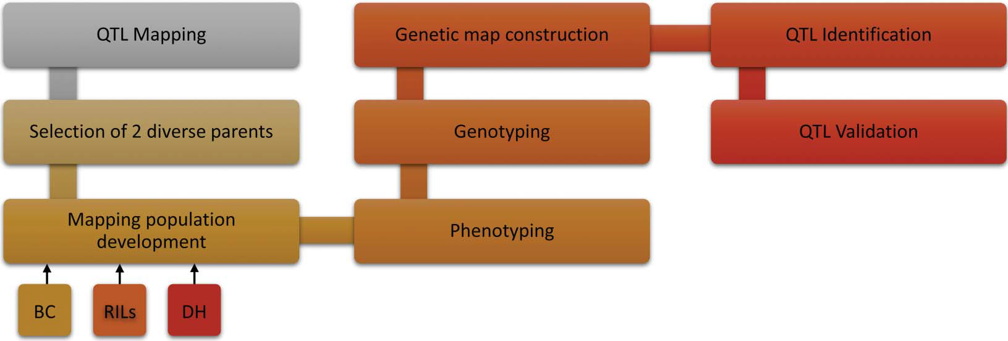 Fig. 1 QTL mapping methodology.

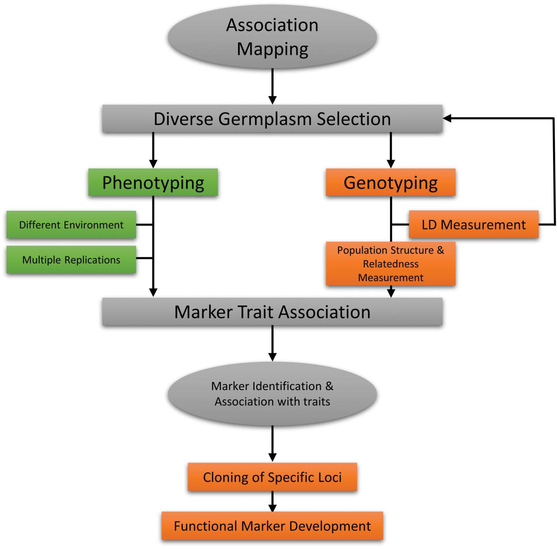

**Fig. 2. Methodology of association mapping.**



**Fig. 3 Some important steps involves in MAS.**

**L. 11.** *The main directions and tasks for**integration of microorganisms and plant systems for food security.*

Ensuring food security in an environmentally sustainable way is a global challenge. To achieve this agriculture productivity requires increasing by 70 % under increasingly harsh climatic conditions without further damaging the environmental quality (e.g. reduced use of agrochemicals). Most governmental and inter-governmental agencies have highlighted the need for alternative approaches that harness natural resource to address this.

Use of beneficial phytomicrobiome, (i.e. microbes intimately associated with plant tissues) is considered as one of the viable solutions to meet the twin challenges of food security and environmental sustainability.

A diverse number of important microbes are found in various parts of the plant, i.e. root, shoot, leaf, seed, and flower, which play significant roles in plant health, development and productivity, and could contribute directly to improving the quality and quantity of food production. The phytomicrobiome can also increase productivity via increased resource use efficiency and resilience to biotic and abiotic stresses. In this article, we explore the role of phytomicrobiome in plant health and how functional properties of microbiome can be harnessed to increase agricultural productivity in environmental-friendly approaches.

However, significant technical and translation challenges remain such as inconsistency in efficacy of microbial products in field conditions and a lack of tools to manipulate microbiome in situ. We propose pathways that require a system-based approach to realize the potential to phytomicrobiome in contributing towards food security. We suggest if these technical and translation constraints could be systematically addressed, phytomicrobiome can significantly contribute towards the sus-

tainable increase in agriculture productivity and food security.

**Lec. 12.** *Engineering drought and salinity tolerance traits in crops through CRISPR-mediated genome editing: Targets, tools, challenges, and perspectives*.

The global malnutrition burden imparts long-term developmental, economic, social, and

medical consequences to individuals, communities, and countries. The current

developments in biotechnology have infused biofortification in several food crops to

fight malnutrition.

However, these methods are not sustainable and suffer from several

limitations, which are being solved by the CRISPR-Cas-based system of genome editing.

The pin-pointed approach of CRISPR-based genome editing has made it a top-notch

method due to targeted gene editing, thus making it free from ethical issues faced by

transgenic crops.

The CRISPR-Cas genome-editing tool has been extensively used in crop

improvement programs due to its more straightforward design, low methodology cost,

high efficiency, good reproducibility, and quick cycle. The system is now being utilized in

the biofortification of cereal crops such as rice, wheat, barley, and maize, including

vegetable crops such as potato and tomato.

The CRISPR-Cas-based crop genome editing has been utilized in imparting/producing qualitative enhancement in aroma, shelf life, sweetness, and quantitative improvement in starch, protein, gamma-aminobutyric acid (GABA), oleic acid, anthocyanin, phytic acid, gluten, and steroidal glycoalkaloid contents. Some varieties have even been modified to become disease and stressresistant.

Thus, the present review critically discusses CRISPR-Cas genome editingbased

biofortification of crops for imparting nutraceutical properties.

**Lec. 13.** *Modern agricultural Biotechnology.*

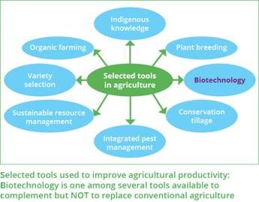

**Lec. 14.** Marker assisted selection in crop plants*.*

* Conventional plant breeding is primarily based on phenotypic selection of superior individuals among segregating progenies resulting from hybridization.
* Breeders are very interested in new technologies to speed up this process or make it more efficient.
* was therefore greeted with great enthusiasm as it was seen as a major breakthrough promising to overcome this key limitation.
* With the advent of DNA-based genetic markers, it became possible to identify large numbers of markers dispersed throughout the genetic material of any species of interest and use the markers to detect associations with traits of interest, thus allow marker assisted selection (MAS) becomes a reality.

*Marker-assisted selection (MAS)*

* is a method of selecting desirable individuals in a breeding scheme based on DNA molecular marker patterns instead of, or in addition to, their trait values.
* When used in appropriate situations, it is a tool that can help plant breeders select more efficiently for desirable crop traits. However, MAS is not always advantageous, so careful analysis of the costs and benefits relative to conventional breeding methods is necessary.

*Different marker types have variable characteristics. Desirable qualities of molecular markers include the following:*

* Polymorphic
* Reproducible
* Evenly distributed across the whole genome (not clustered in particular regions)
* Inexpensive
* Easy to analyse
* Co-dominant (so that heterozygotes can be distinguished from homozygotes)
* Possibility of being outsourced

Future prospects include upscaling of modern technology, enhanced seed production, improved inputs availability and use, improved irrigation, improved agriculture-education-training-research- extension-nexus, reclamation of salinized lands, improved agricultural credit and support price policies. Recommendations include improving agricultural research and extension systems, accelerating diffusion and adoption of latest agriculture technologies and inputs, enhancing good quality seed production, improving irrigation water management and improving reclamation and drainage.

***Lec. 15***  *Organic farming Strategies to overcome crop yield reduction. Development of new adapted crop genotypes The future of food and agriculture.*

* Organic farming also known as ecological farming or biological farming, is an agricultural system that uses fertilizers of organic origin such as compost manure, green manure, and bone meal and places emphasis on techniques such as crop rotation and companion planting.
* It originated early in the 20th century in reaction to rapidly changing farming practices.
* Certified organic agriculture accounts for 70 million hectares (170 million acres) globally, with over half of that total in Australia.

Organic farming methods

A number of global trends are influencing food security, poverty and the overall sustainability of food and agricultural systems.

The world’s population is expected to grow to almost 10 billion by 2050, boosting agricultural demand – in a scenario of modest economic growth – by some 50 percent compared to 2013. Income growth in low- and middle-income countries would hasten a dietary transition towards higher consumption of meat, fruits and vegetables, relative to that of cereals, requiring commensurate shifts in output and adding pressure on natural resources.

Economic growth and population dynamics are driving the structural change of economies.

The decline in the share of agriculture in total production and employment is taking place at different speeds and poses different challenges across regions.

Although agricultural investments and technological innovations are boosting productivity, growth of yields

has slowed to rates that are too low for comfort. Food losses and waste claim a significant proportion of agricultural output, and reducing them would lessen the need for production increases.

However, the needed acceleration in productivity growth is hampered by the degradation of natural resources, the loss of biodiversity, and the spread of transboundary pests and diseases of plants and animals,

some of which are becoming resistant to antimicrobials.

Climate change affects disproportionately food-insecure regions, jeopardizing crop and livestock production, fish stocks and fisheries.

Satisfying increased demands on agriculture with existing farming practices is likely to lead to more intense competition for natural resources, increased greenhouse gas emissions, and further deforestation and land degradation.